STATEMENT OF PURPOSE

The Farmhouse

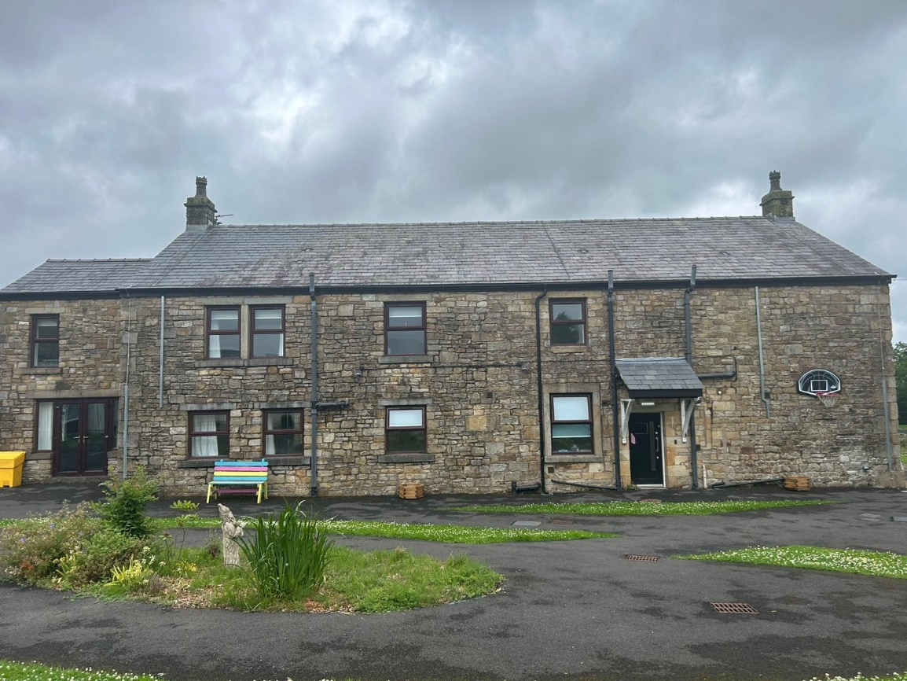

Cambian The Farmhouse

Ward Green Lane,

Ribchester, PR3 3YB

Tel: 01254 958579

SOP Completed: 24.06.2025

Ofsted- Registration Number: Currently in the process of registering the home

**Contents**

1. Organisational Overview

Cambian Group

1. Quality and Purpose of Care

Position statement

Ethos of the home (progressing outcomes)

Description of accommodation

Location of the home

Arrangements for supporting cultural, linguistic and the religious needs of children and young people

Complaints

Access to safeguarding and behaviour management policies

1. Views, Wishes and Feelings

Consultation and approach to consulting children and young people on quality of care

Anti-discriminatory practice in respect of children and young people and their families

Children’s and young people’s rights

1. Education

Special Education Needs

Assessment and recording

Guidance and support

Arrangements for education reviews.

Details to support children and young people with Special Educational needs.

1. Enjoy and Achieve

How we ensure the children and young people enjoy and achieve

1. Health

Arrangements to Protect and Promote Health

Details of the qualifications and professional supervision of staff involved in providing healthcare or therapy

1. Positive Relationships

The arrangements for promoting contact between children, their families and friends

1. Protection of Children

The Homes approach to monitoring and surveillance of children

The vetting of staff and visitors to the home.

Supervision of the young people

The home’s approach to physical intervention in relation to children.

How persons working in the home are trained in physical intervention and how their competence is assessed.

1. Leadership and Management

Details and work address of the Registered Provider, Responsible Individual and Registered Manager

Details of the experience and qualifications of staff, including any staff commissioned to provide health care.

Details of the staff/management staffing structure of the home and training

Gender status of the home and positive role models.

Professional supervision arrangements for care staff and health care professionals.

1. Care Planning

Any criteria used for the admission of children of the home, including any policies and procedures for emergency

admission.

Planned referrals to the home.

Emergency referrals

Planned admissions to the home

Farm House

1. Organisational Overview

We, at Cambian Group, are one of the largest providers of specialised care in the UK. We cater for both children and young adults including those with challenging behaviours complex needs, Autism, and Learning Disabilities. We offer specialist education, residential, mental health provisions and fostering services, ensuring that each child or young person and young adult in our care achieve their personal best. At Cambian Group we provide tailored care packages in therapeutic environments and our highly dedicated and experienced staff teams support individuals to empower them to progress towards a better life and prepare them to live as independently as they can. We provide services for more than 2,400 individuals in 286 services. We work with over 140 local authorities and employ more than 6,000 people. Our children’s services aim to meet the needs of children across the spectrum of care.  We provide a range of specialist services that support this ambition providing where possible every child the care, therapy and learning they need to ensure they achieve their personal best. We focus on delivering clear outcome for each person in our services.

2. Quality and Purpose of Care

# Position Statement

The Farmhouse is proudly located within the grounds of Brook View School, which is part of the Cambian Group Ltd. and CareTech Holdings Ltd. We are dedicated to providing a high standard of care for up to four children and young people, aged between 8 and 18 years. Our residential provision, available for 38 and 52 weeks, warmly supports both boys and girls who have a diagnosis of Autism Spectrum Disorder (ASD) and associated difficulties/challenges, or are on the ASD pathway. Many of the young people we care for are on the ASD pathway and may have experienced trauma or related challenges. We understand that each young person’s journey is unique. Our focus is always on thoughtful, individualised planning that meets every aspect of their needs.

Some of our children and young people may have associated learning difficulties, communication difficulties or other potential barriers and at times they may display challenging behaviours. All of the children and young people will have an Education Health Care Plan (EHCP) to support their progress academically, socially and health etc. Farmhouse, in conjunction with Brook View School, maintains an ethos of individual learning through experiences with the aim to support our children and young people to achieve a level of independence and appropriate community access which is bespoke for each individual young person. This will include integrated clinical and therapeutic support through Brook View School.

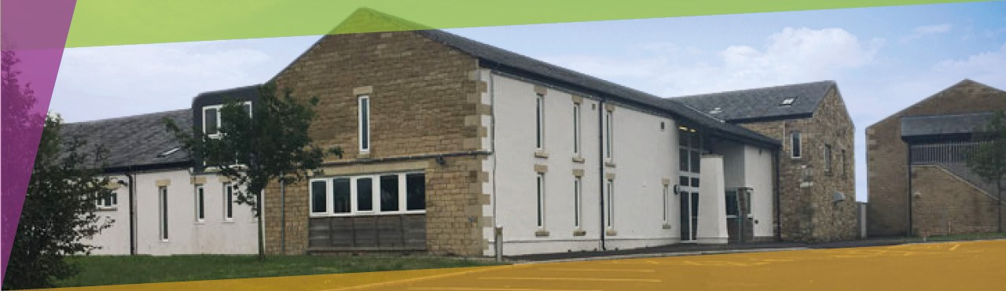

**Ethos of the Home (Progressing Outcomes)**

The aim of The Farmhouse is for each child and young person to achieve their personal best, tailored to their individual care needs with support from staff and external agencies. Everything we do is focused on helping them reach their unique goals.

Our key objectives include improving communication and social skills, fostering progress in self-management of behaviours, enhancing independence and life skills, and increasing self-awareness of physical health and wellbeing. These outcomes are supported by providing a nurturing and safe environment that children and young people can truly consider their home.

We employ a Total Communication approach to ensure that each child’s feelings and wishes are heard. Children and young people are actively consulted and given choices about various aspects of their care, from meal options to off-site activities.

Our multicultural environment promotes a strong sense of belonging and allows children and young people to celebrate and express their own cultures and beliefs. A positive, multidisciplinary approach is embedded within both the home and school settings.

The wellbeing of every child and young person remains our highest priority. Through mutual respect, we strive to create a happy and supportive environment for all who live and work at The Farmhouse.

# Description of Accommodation

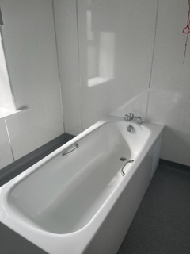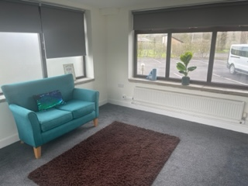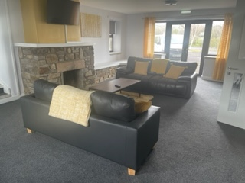The Farmhouse is a spacious seven-bedroom home, each room benefiting from its own en-suite facilities to ensure privacy and comfort for every resident. The property features two welcoming communal lounges, thoughtfully designed to encourage social interaction and relaxation.

For those with creative interests, there is a dedicated area for arts, crafts, and games, providing a stimulating and enjoyable environment.

The home includes a well-appointed communal kitchen and dining room, fostering a sense of community during meal times, as well as a practical utility room to support daily living needs.

The Farmhouse offers a warm and nurturing environment where comfort and safety are paramount. Each bedroom is furnished and decorated to a high standard, with familiar furniture and surroundings that help our children and young people feel secure and at home. The rooms are carefully maintained, with safety always at the forefront of our care.

Children and young people are actively involved in selecting the décor and personalising their bedrooms, supported by their keyworker to express their individual style and preferences.

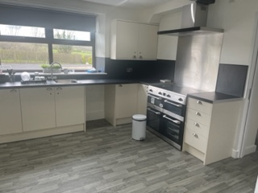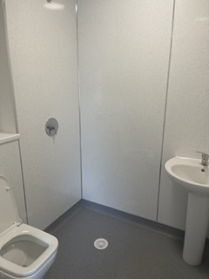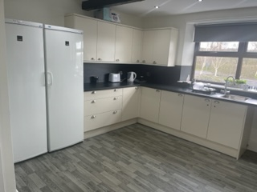Outside, there is a secure garden featuring a picnic bench and a well-maintained play area, providing a safe and enjoyable space for young people to relax and have fun. They are also encouraged to participate in planting and tending to the garden, which helps develop their skills and allows them to see their favourite colours flourish in a space they have helped create.

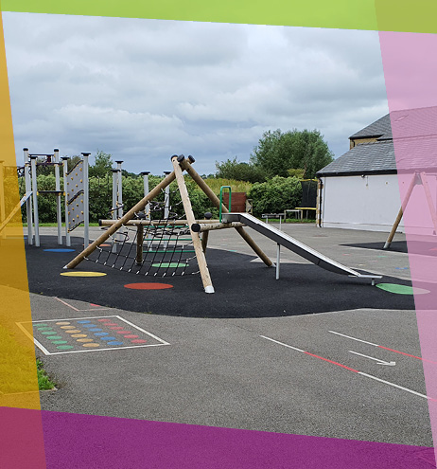At The Farmhouse, home and school work closely together to provide a holistic approach that addresses both the academic and social development needs of each child and young person. Our learning-centred philosophy ensures that all aspects of care and education are tailored around the individual, maximising their chances of success.

Care and education teams collaborate to create joint Individual Education Plan (IEP) targets that reflect the current needs of each young person. Progress is carefully monitored and evidenced in both the home and school settings.

Weekly team meetings involving care, clinical, and education staff ensure continuous communication and review. During these meetings, evidence from quality of life indicators is shared to track progress against IEP goals, guaranteeing coordinated support that enhances outcomes for every child and young person in our care.

Location of the Home

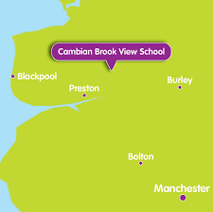The Farmhouse is ideally located in Ribchester, near Preston in Lancashire, offering the perfect balance of rural tranquillity and convenient access to local amenities.

Situated within the grounds of Brook View School, this peaceful rural setting provides a safe and nurturing environment, while still being close to a welcoming village and town. The home benefits from excellent public transport and bus links, making travel straightforward and accessible.

Just a short journey away are the popular seaside towns of Blackpool and Southport, perfect for day trips and recreational activities. For shopping and everyday needs, the nearby city of Preston offers a wide variety of retail options including clothing stores, supermarkets, and other essential facilities.

The local area boasts an abundance of cultural and recreational amenities such as parks, libraries, sports centres, and religious and cultural venues. The Farmhouse enjoys a positive and friendly relationship with its neighbours and the surrounding community, creating a warm and inclusive atmosphere.

Additionally, a wealth of entertainment and educational opportunities are within easy reach, including cinemas, museums, theatres, and bowling alleys — providing plenty of options for leisure and enrichment.



# Arrangements for supporting the cultural, linguistic and religious needs of children and young people.

At The Farmhouse, we are committed to respecting and supporting the diverse cultural, linguistic, and religious backgrounds of all children and young people in our care. We recognise that a strong sense of identity and belonging is essential to their wellbeing and development.

We work closely with each child and their family to understand their individual cultural and religious needs, ensuring these are reflected in daily life at The Farmhouse. This includes providing opportunities to observe cultural traditions, celebrate important festivals, and access religious support or places of worship as required.

Our staff receive regular training to develop cultural competence and awareness, enabling them to communicate effectively and sensitively with young people from a range of backgrounds. We also encourage the use of children’s preferred languages and support any necessary language development through personalised communication strategies.

Through these efforts, we aim to create an inclusive environment where every child and young person feels valued, respected, and able to express their identity fully.

# Complaints

At The Farmhouse, we are committed to providing a safe, supportive, and respectful environment for all children and young people in our care. We understand that sometimes concerns or issues may arise, and we want to ensure that these are addressed promptly and fairly.

If you have a complaint about any aspect of care, treatment, or the environment at The Farmhouse, you are encouraged to raise it without delay. Complaints can be made by the child or young person themselves, their family members, advocates, or other representatives.

**How to Raise a Complaint:**

1. **Speak to a Member of Staff:**  
   In many cases, concerns can be resolved informally by speaking directly to a member of staff, such as the child’s keyworker or the residential manager. They will listen carefully and work with you to address the issue.
2. **Contact the Registered Manager:**  
   If you feel the matter has not been resolved or you prefer to raise the complaint formally, you can contact the Registered Manager of The Farmhouse. Contact details are provided to all families upon admission and are also available within the home.
3. **Formal Complaint Procedure:**  
   The Farmhouse has a clear complaints procedure which ensures all complaints are recorded, investigated thoroughly, and responded to within a specified timeframe. You will be kept informed of the progress and outcome.
4. **Independent Advocacy and External Support:**  
   Children and young people are encouraged to seek support from independent advocates who can help them raise their concerns. Additionally, complaints can be escalated to external bodies such as Ofsted or the local authority safeguarding team if necessary.

Your feedback is invaluable in helping us improve the care and services we provide. At The Farmhouse, we take every complaint seriously and are committed to making sure your voice is heard.

**A copy of the Complaint Policy can be requested from any member of staff, the Registered Manager or the Responsible Individual.**

At The Farmhouse, we fully recognise that some of our children and young people may experience difficulties in expressing concerns or making complaints through spoken language alone. That’s why we are fully committed to using a *Total Communication Approach* to ensure that every individual, regardless of their communication needs, is supported to have a voice and feel confident in expressing their views, concerns, or worries.

Total Communication means we use a range of methods tailored to each young person – including speech, signs, symbols, gestures, communication aids, visual supports, and written materials – to make information accessible and meaningful. We work with each child to understand how they best communicate and adapt our approach accordingly.

When a child or young person is admitted to The Farmhouse, their key worker will carry out an individual session to explain the complaints process using their preferred communication style. This session is carefully adapted to the child’s developmental level and understanding, using visuals or alternative formats as required. The complaints procedure is broken down into simple, manageable steps, and the standard complaints form can be personalised to make it more accessible to the young person.

To support ongoing awareness and understanding, accessible and child-friendly complaints posters are displayed throughout the home. These use a combination of symbols, pictures, and clear, simple language to ensure all children and young people know how to raise a concern and who they can talk to.

Our team is trained in delivering care through a Total Communication Approach, ensuring that all interactions are inclusive and that no child’s voice goes unheard. We are committed to creating a safe, open, and empowering environment where every child and young person feels respected, listened to, and supported in raising any concerns they may have.

# Safeguarding and Behaviour Management Policies

* At Farmhouse, we are committed to providing a safe, nurturing, and supportive environment for young people with complex needs, including those on the autism spectrum (ASD). Our approach to safeguarding and behaviour management is underpinned by the principles of Positive Behaviour Support (PBS), a person-centred, evidence-based framework that promotes understanding, respect, and proactive support to reduce distress and challenging behaviour.

**Safeguarding Principles**

* **Child-Centred Culture:** We prioritise the voices, rights, and wellbeing of each young person. Recognising that many of our young people have limited expressive communication, we ensure all staff are trained to observe and interpret non-verbal cues and behaviours as forms of communication.
* **Skilled and Supported Workforce:** Staff receive ongoing training in safeguarding, autism awareness, communication strategies, and PBS to ensure they are equipped to respond effectively to the unique needs of our young people.
* **Collaborative Multi-Agency Working:** We maintain strong partnerships with social care, health, education, and advocacy services to ensure holistic safeguarding and support.
* **Robust Monitoring and Reporting:** All safeguarding concerns are recorded, reported, and reviewed promptly in line with statutory guidance and local safeguarding protocols. Leadership fosters an open culture where staff feel confident to raise concerns without fear of reprisal.
* Behaviour Management Using Positive Behaviour Support (PBS)
* PBS is central to our behaviour management approach. It involves understanding the function of behaviour, the impact of the environment, and the individual’s communication needs to develop tailored, proactive support plans.
* **Key Components:**
* **Functional Behaviour Assessment:** Staff conduct detailed assessments to identify triggers, antecedents, and consequences of behaviours. This informs personalised PBS plans.
* **Person-Centred Planning:** Each young person’s PBS plan is developed collaboratively with them (where possible), their families, and professionals, focusing on strengths, preferences, and needs.
* **Proactive Strategies:** We emphasise environmental modifications, structured routines, visual supports (e.g., schedules, choice boards), and sensory regulation to reduce anxiety and prevent behaviours of concern.
* **Communication Support:** Use of Makaton, visual aids, and other augmentative communication methods is embedded to enhance understanding and expression, reducing frustration and distress.
* **Teaching Alternative Skills:** Young people are supported to develop functional communication, emotional regulation, and social skills as positive alternatives to challenging behaviour.
* **Reactive Strategies:** When behaviours do occur, staff respond with empathy, de-escalation techniques, and safe, least-restrictive interventions aligned with the PBS plan. Physical interventions are only used as a last resort and in accordance with legal and ethical standards.
* **Staff Roles and Responsibilities**
* **Keyworkers:** Provide consistent, trusted relationships, implement PBS plans, and advocate for the young person’s needs.
* **All Staff:** Maintain vigilance for safeguarding concerns, apply PBS strategies consistently, and contribute to behaviour monitoring and reporting.
* **Leadership:** Ensure staff training, quality assurance, and a positive safeguarding culture. Regularly review PBS plans and safeguarding practices to promote continuous improvement.
* **Environment and Routine**
* The physical environment is adapted to minimise sensory overload and support safety.
* Structured daily routines with clear ‘now and next’ visual schedules help reduce uncertainty and anxiety.
* Opportunities for choice and autonomy are provided to empower young people and promote engagement.
* Advocacy and Family Involvement
* Young people have access to independent advocacy services tailored to their communication needs.
* Families are actively involved in care planning and safeguarding discussions, ensuring cultural sensitivity and respect for identity.
* **Continuous Improvement**
* We regularly review safeguarding incidents and behaviour data to identify trends and improve practice.
* Staff receive reflective supervision focused on safeguarding and PBS implementation.
* We engage with current research and best practice guidance to enhance our service delivery.

3. Views, wishes and feelings:

# Consultation and approach to consulting children and young people on quality of care

The aim of Farm House is to enable each and every one of our children and young people to achieve their personal best; however, it is defined by them or for them. Everything we do is directed towards achieving this aim. Key objectives for our children and young people are;

* the improvement of communicative skills, social skills including progress in self-management of behaviour
* to increase self-awareness of physical health and well-being.
* Build independent skills such as cooking, personal care etc
* To lead a good and healthy life
* To develop self-regulation skills
* To having meaningful 1:1 sessions to express views, wishes and feelings.
* To achieve social skills and to attend activities in which they will enjoy
* To ensure family contact is consistent and planned well
* To attend school and receive good education
* Realistic goals such as tying shoe laces, toilet training
* To respect each and one another in and outside the home

Using visual aids, communication mats, tablets and other communication aids, our children and young people are consulted about different aspects of their care, from school food to off-site activities. We have a non-aversive, positive multi-disciplinary approach which is integrated across all settings.

It is vital that all children and young people have a range of means by which to communicate their views and thoughts. Our Speech and Language therapist ensures staff are familiar with individual’s preferences and styles of communication.

**Anti-discriminatory practice in respect of children and young people and their families;**

We believe that children and young people with additional needs should share the same rights as all members of society, where these are appropriate and in their best interests.

Within the statutory framework provided by current legislation and regulations, staff at Farm House work to protect and promote the right for all people with special needs:

* + to live full and independent lives to the maximum of their potential to a full, accurate and unbiased assessment of their special needs
  + to a range of education, care, health and other associated support services required to meet all their needs
  + to be involved in decisions affecting their lives and to have their wishes, as far as possible, ascertained, and respected
  + to appropriate guidance, counselling and care which promote their physical, mental, and spiritual health and well-being
  + to safe, attractive, and comfortable living accommodation with privacy, to adequate food, clothing, space and other necessities of life
  + to the equipment, assistance and support services needed to enable them to live with dignity
  + to the degree of freedom of movement which is consistent with their health, safety and well-being to participate in and benefit from cultural, entertainment, recreational and sporting activities where possible, to use facilities and services in the community
  + to develop relationships without exploitation or coercion to the full protection of the law
  + to be protected from all forms of abuse and from the fear or threat of abuse
  + of access to information contained in their personal records, where this does not conflict with statutory regulations or threaten their well-being
  + to supportive intervention to promote positive behaviour and to protect them from harm
  + of access to suitably qualified, experienced, and sympathetic staff in sufficient numbers to maintain quality of service
  + to financial support sufficient to maintain their quality of life
  + to have links with home and family, promoted and maintained to positive recognition of cultural and religious diversity.
* The Behaviour Support Policy provides a clear framework for staff to implement Positive Behaviour Support (PBS) in practice. Our commitment is to empower people with complex needs to lead lives of choice and control, with access to valued opportunities. PBS is particularly relevant for those we support, as it relies on systematically gathering quality information from those who know the person best, rather than relying on subjective opinions.
* As support providers, we have a responsibility to understand the reasons behind certain behaviours and to reflect on how our responses may influence them. PBS is grounded in psychological theory and guided by person-centred values. Many behaviours serve as important ways for people to communicate needs—such as seeking attention, a preferred object, or wanting to avoid certain situations—especially when communication is difficult. Our role is to understand the complex factors influencing behaviour and to support individuals in expressing their needs safely and effectively.

AIM

This policy will detail the PBS process in Positive Support for You and how both the commitment and values of maximising choice and control and understanding behaviours of concern are embedded in organisational structure, leadership, person centred planning and reviews, training of our support staff, supervisions and team meetings to ensure excellent outcomes for the people we support. In short, we aim …

To ensure Positive Behaviour Support has Lead Practitioners to provide support, training and leadership in PBS and ensure strong partnerships with multidisciplinary teams. (Dominique Dawson is a trained BILD PBS Coach / Instructor)

To ensure we understand, prevent and manage behavioural incidences.

To ensure we understand the possible meanings and function of the behaviours of concern.

To ensure the least restrictive option is always pursued.

To ensure support teams understand all aspects of the support plan.

To ensure positive outcomes for the people we support.

**Positive Behavioural Support**

PBS is embedded in psychological theory and applied behaviour analysis and has a scientific basis. It’s a framework to help analyse behaviour and collect good quality information so we can understand the function of certain behaviours. It is a framework based on positives, not withdrawing items or having punitive results, but of life enhancing growth and development to achieve similar outcomes in more positive ways. As such the plan will involve the person or attempted involvement of the person, family, friends and advocates and paid carers supporting the person. It will also be conducted in a manner consistent with the Mental Capacity Act 2005.

Challenging behaviour is a social construct shaped by our expectations and often arises when individuals experience limited opportunities, lack meaningful activity, or face barriers to communication and social connection. Factors such as trauma, poor health, frequent staff changes, loneliness, and mental health issues can increase vulnerability to behaviours of concern. These behaviours usually serve important functions—such as seeking stimulation, attention, preferred items, or avoiding demands—and are influenced by a complex mix of personal, environmental, and emotional factors. It is essential that only individuals who display, or are at risk of displaying, challenging behaviour have a Positive Behaviour Support (PBS) plan tailored to their needs.

**ASSESSMENT**

Before creating a PBS plan, a comprehensive assessment is carried out with input from the person, their key supporters, and professionals. This includes reviewing current records, assessments, and daily reports such as ABC charts. PBS training ensures staff understand the person’s preferred social interactions, communication style, and the need for consistent language and respect for individual routines and cues. Sensory preferences, independence, and choice are considered in the environment, and physical health needs, including pain management, are regularly reviewed.

**POSITIVE BEHAVIOUR SUPPORT PLAN**

A good Positive Behaviour Support (PBS) plan helps individuals lead more fulfilling lives by understanding the function of their behaviours and supporting safer, more effective alternatives. The plan is developed using systematic, data-driven information—gathered from those who know the person well—rather than subjective opinion. It is based on a functional assessment and includes both proactive and reactive strategies to maximise safety, teach coping skills, and help staff understand their own impact. Quality data, such as direct observations of frequency, duration, and intensity of behaviours, informs the plan, while indirect data from records and team input is also considered, though it may be more subjective. Person-centred planning remains central throughout

**PROACTIVE STRATEGIES**

Proactive strategies in a Positive Behaviour Support (PBS) plan are designed to ensure the person’s needs and preferences are met, reducing the likelihood of behaviours of concern. A good plan includes detailed information on what the person enjoys, their motivators, and any support needed to learn new skills or communicate effectively. It outlines how to help the person relax, make choices, and participate in meaningful activities, aiming to prevent behaviours of concern by promoting positive alternatives and clear communication. These strategies are person-centred and focus on positive outcomes and life-enhancing opportunities.

**PERSON CENTRED PLANNING**

A strength-based assessment is central to our approach, ensuring that each person’s likes, dislikes, aspirations, and opportunities are understood before addressing behaviour. This underpins a Positive Behaviour Support (PBS) plan that does not define individuals by their behaviours, but instead focuses on their strengths and preferences. Our trained person-centred planning facilitators and special interest group ensure that formal plans are linked to individual goals, outcomes monitoring, and regular reviews. Plans are developed collaboratively with the person and their family, incorporating choice and personal preferences, which is essential for creating effective proactive support strategies. Ultimately, PBS should empower individuals to develop and achieve their personal goals in life

**COMMUNICATION**

Effective communication is a key aspect of any quality support. Understanding how a person communicates whether it be verbally or non-verbally through their actions is a core support skill, as is active listening. PBS plans will describe the person’s unique character and the most effective means of communicating for successful interactions. The PBS plan incorporates a communication profile to ensure we are supporting the person to express their needs, emotions and choices.

**REACTIVE STRATEGIES AND DATA**

Reactive strategies are designed to keep individuals safe and provide staff with clear, step-by-step guidance on how to respond quickly and effectively if a person becomes distressed or exhibits behaviours of concern. These plans prioritise early intervention to prevent escalation, using non-restrictive approaches such as de-escalation, distraction, and withdrawal from triggers whenever possible. Physical intervention, medication, or other restrictive measures are only considered as a last resort, always supported by a clear rationale and multidisciplinary assessment, and must be the least restrictive option necessary to maintain safety.

We are committed to the STOMP agenda, seeking to understand the function of behaviours, analyse data, and adapt environments to reduce triggers. Our skilled staff, including those qualified to Level 4 in PBS, use data from direct observation and team discussions to review and refine our approaches. Team meetings ensure support staff are actively involved in developing and implementing these plans. As a result, we have seen significant reductions in the use of restrictive interventions and improvements in quality of life for those we support. Data on ABCs, PRN usage, and safety interventions is regularly reviewed to monitor progress and inform best practice

**SAFETY INTERVENTIONS AND LEAST RESTRICTIVE PRACTICE**

We provide staff with training in Safety Interventions to support effective implementation of reactive plans. Experienced managers play a crucial role in guiding staff teams and ensuring that our safety and wellbeing assessments enable positive risk-taking tailored to each individual’s needs. These assessments are informed by Positive Behaviour Support (PBS) plans and person-centred risk assessments.

Our approach emphasises managing incidents of aggression with non-aversive, de-escalation techniques, with staff withdrawal as a preferred option when appropriate. Training covers recognising levels of behaviour, appropriate responses, and the importance of both verbal and non-verbal communication. Staff are taught to offer choices early, avoid sensory overload, and use redirection to prevent escalation. The focus is always on seeing the person’s strengths and individuality, not just the behaviour.

Physical interventions are taught only as a last resort, after all other strategies have been exhausted, and are designed to protect everyone from harm without teaching self-defence. All interventions are independently assessed for safety. Staff record incidents using ABC charts, and any harm is documented and reviewed by PBS practitioners and managers as part of our ongoing review process. In practice, physical intervention is rarely required, as proactive strategies and early responses are usually effective

**LEADERSHIP AND LEARNING AND DEVELOPMENT.**

We are committed to enhancing people’s lives through proactive strategies and the systematic collection of data to understand the function of behaviours of concern. Our teams are trained in Positive Behaviour Support (PBS) with a strong emphasis on human rights and non-restrictive practice. In addition to formal training, we use team meetings to deliver targeted restrictive practice training relevant to each service and prioritise quality of life and values-based training as foundations for our approach.

Restraint—defined as any act that restricts an individual’s movement or freedom, with or without physical force—is only considered as a last resort, and always with clear rationale and multidisciplinary input. Our focus is on understanding all behaviours as forms of communication, completing functional assessments when needed, and involving the whole team in developing non-restrictive, person-centred strategies to minimise behaviours of concern

**Review**  
Review is an ongoing process to ensure the effectiveness of strategies addressing behaviours of concern and to assess staff consistency. Monitoring is typically more intensive at the outset, with Team Managers and PBS practitioners analysing documentation and outcomes. Strategies are regularly reviewed and adjusted in team meetings, involving the individual, their supporters, and the multidisciplinary team.

**Children’s Rights**  
We are deeply committed to upholding and promoting the rights of the children and young people in our care. This commitment is embedded in every aspect of our provision. We actively ensure that each child’s voice is heard and respected, and that their rights to safety, dignity, participation, and development are central to our practice. Our policies and daily routines are designed to empower children to express their views, make choices, and participate meaningfully in decisions affecting their lives. We work in partnership with families, advocates, and professionals to safeguard these rights, and we regularly review our practice to ensure it aligns with both statutory guidance and the principles of the United Nations Convention on the Rights of the Child. Through this rights-based approach, we aim to create an environment where every child feels valued, protected, and supported to reach their full potential

1. Education:

* We are committed to providing a structured, inclusive, and supportive environment where all children and young people, including those with special educational needs (SEN), are valued and empowered to reach their full potential. Recognising that each child is unique and develops at their own pace, we work closely with parents, external agencies, and Brookview School to ensure every individual’s needs are met.
* Children and young people with SEN are fully included in our provision at Farmhouse and treated with respect and dignity, free from discrimination. We actively seek guidance from relevant agencies and participate in Annual Reviews and Individual Development Plans (IDPs) to support each young person’s educational journey.
* We understand that many of the children and young people we care for may have missed schooling, experienced gaps in learning, or lost confidence in their abilities. Our team, in partnership with Brookview School, supports learning both in and out of the classroom, tailoring opportunities to individual needs and encouraging active participation in planning and decision-making.
* Assessment is ongoing and progress is regularly shared at review meetings. We work to integrate staff expertise, promote quality of life indicators, and support staff training to ensure the best possible educational and developmental outcomes for every young person at Farmhouse.

|  |
| --- |
| Arrangements for Education Reviews  Weekly reviews are held at site level between care, clinical and education. Actions are taken during these documented meetings and meetings requested with professionals should it be required due to risks, behaviours or concerns around a child’s or young person’s placement. |

# Details of provision to support children and young people with special educational needs.

Each child or young person has an Individual Development Plan (IDP) linked to their Education Health and Care Plan (EHCP), developed collaboratively by care, education, and therapeutic staff to ensure consistency and support small steps of progress. Outcomes are monitored continuously by staff, with formal reviews held termly during EHCP Outcomes meetings. Brook View benefits from access to Cambian’s diverse multi-disciplinary clinical team, who work closely with care and education staff to provide training and support, ensuring that all EHCP needs and objectives are met. Clinicians contribute to IDP targets and set or review clinical intervention goals based on individual assessments and functional needs

5. Enjoyment and Achievement:

# How we ensure the children and young people enjoy and achieve

All children and young people at Farm House are supported to participate in a wide range of leisure activities that reflect their individual interests, abilities, culture, and beliefs. We celebrate birthdays, cultural, and religious festivals, and encourage children to plan activities and special events with staff. Staff use keyworker sessions and meetings to help children explore new and existing interests, including community activities and creative pursuits such as art, music, and reading.

We make use of local community resources and the Local Offer to ensure inclusive access to activities like sports, clubs, and classes. Children from diverse backgrounds have their cultural and religious needs met through links with specialist agencies and local communities, and we promote multicultural awareness throughout the home.

Positive achievements are recognised and rewarded through the ‘Epraise’ system, which encourages positive behaviour, participation, and personal development both at school and at home

6. Health:

Arrangements to protect and promote health.

Staff play a vital role in promoting health and wellbeing for young people at Farmhouse, particularly those with autism and complex needs. We ensure all children and young people are registered with local health services and have access to regular medical, dental, and optical care, with choices available to suit individual preferences. Health needs are promptly addressed, and up-to-date health records are maintained for each child.

Keyworker sessions provide opportunities for young people to discuss any health concerns, which are acted upon quickly. Medication and health plans are regularly reviewed, and annual health assessments ensure individual needs are met. Where weight or nutrition is a concern, tailored action plans and support from external professionals, such as dieticians, are provided, along with encouragement to participate in suitable physical activities.

Staff deliver proactive health education, adapted for young people with ASD, focusing on healthy living, personal care, and wellbeing. All health promotion is delivered in a structured, supportive way that respects each young person’s communication style and sensory needs

7. Positive Relationships:

# The arrangements for promoting contact between children and young people and their families and friends.

The team at Farmhouse work in partnership with parents and carers to promote regular contact through on-site and off-site visits which will be supported according to need. The use of regular weekly reports ensures parents and carers are fully aware of up to date news and able to refer to this during regular telephone or skype contact as arranged. All children and young people send regular letters to parents, often in symbol and picture form, and parents are invited to share key events such as the annual carol service, sports day and birthday parties etc. Social workers are also included in all communication and updates to ensure all progress and challenges can be shared and managed with a transparent and supportive approach.

**8. Protection of Children:**

# The home’s approach to the monitoring and surveillance of children and young people.

Children’s and young people’s use of electronic devices in Farmhouse is filtered and monitored using an industry recognised system Fortigate. There is no CCTV on site. Some of our children may require monitors in their bedrooms to keep themselves safe, steps to ensure young people’s safety are paramount and we follow legislation around the young person’s placements and status to ensure authorization is paramount and the needs of the young people are upmost.

**The vetting of staff and visitors to Farmhouse.**

The procedure for the vetting of staff and visitors of Farmhouse is as follows. Any visitors to Farmhouse will be asked for ID and we will verify directly with the company they represent if we have any concerns.

Staff who are sent to work on site from any other Cambian homes will be asked to bring a copy of their DBS and ID; we will speak with the home’s managers if we have any concerns. They will be asked to sign in.

**Supervision of Children and young people**

Day and night prior to a child or young person’s placement at Farmhouse, a supervision level will have been agreed in consultation with the placing authority. Appropriately trained and experienced staff will be detailed to work with the child or young person on a rota basis. Children and young people will have an identified core team who will be primarily responsible for their care. Once at capacity, during the night there will be waking night staff and sleep-in staff onsite.

**The approach to physical intervention in relation to children and young people;**

We follow statutory guidance from Keeping Children Safe in Education and the Children’s Homes (England) Regulations 2015 to ensure the safety and welfare of all children and young people at Farmhouse. Physical intervention is only ever used as a last resort, and solely to prevent injury or serious property damage.

All staff are trained in Safety Intervention techniques, and every child or young person has an Individual Risk Assessment and Positive Behaviour Support Plan in place before admission. These plans are regularly reviewed, especially after any incident, to ensure risks are managed and minimised. Behaviour management strategies are discussed with parents, carers, and placement representatives during the admission process to ensure transparency and consistency

All staff at Farmhouse receive formal training in Safety Intervention—a recognised, holistic behaviour management approach that includes both proactive and, as a last resort, reactive physical intervention strategies. Training is delivered in-house by certified trainers, and staff are assessed for competence in ability, attitude, and knowledge during these sessions. Only those who have successfully completed the training and demonstrated competence are authorised to use physical intervention techniques.

Staff must attend mandatory annual refresher training to maintain their skills and authorisation. Their competence is continually monitored through management oversight, incident debriefs, and quality assurance processes. After any incident involving physical intervention, a manager reviews the event, speaks with the child or young person involved, and ensures their views are recorded and that they are offered support, including access to an advocate or independent person.

Staff follow detailed policies and procedures, sign declarations confirming their understanding, and receive regular safeguarding updates. This ensures that physical intervention is always used safely, proportionately, and only as a last resort, with a strong emphasis on positive, non-restrictive practice

**9. Leadership and Management:**

**Details of Registered Provider, Responsible Individual and Registered Manager**

**The Registered Provider**

Cambian Autism Services Ltd.

Metropolitan House,

3 Darkes Lane

Potters Bar

Hertfordshire

EN6 1AG

Tel: 0208 735 6150

**The Responsible Individual**

Vacant

**The Registered Manager**

Vacant

Cambian Brook View School

Ward Green Lane

Ribchester

PR3 3YB

Tel: 01254 942362

**Details of Management/Staffing Structure and Training.**

All staff at Farmhouse, managed by the Cambian Group, complete a two-week induction before starting work, which includes e-learning, safeguarding training, and time in the school setting to build positive relationships with young people. Staff are supervised by a manager or Team Leader every 6–8 weeks, with additional sessions as needed for new staff or specific support.

Care staff are required to achieve or work towards NVQ Level 4 in Children’s and Young People’s Workforce after a 6-month probationary period. Regular supervision, appraisal, and ongoing training ensure staff are supported in their roles and professional development, with Performance Improvement Plans (PIPs) or Personal Development Plans (PDPs) implemented as necessary.

**Professional Supervision arrangements for care staff and Health Care Professionals.**

All contracted staff at Farmhouse receive regular supervisions, with supervisors and supervisees matched to support staff development. Supervisions are held in a supportive, confidential setting during quieter times to allow for open discussion. New staff have a 6-month probationary period, after which they continue to receive ongoing supervision and appraisal. Managers ensure staff understand their roles, can raise concerns, and know their lines of accountability.

1. Care Planning:

# Any criteria used for the admission of children to the Home, including any policies and procedures for emergency admission.

Most children and young people at Farmhouse are referred and placed by local authorities, with support from Social Services and sometimes Health Services, though direct approaches from parents/carers are also considered. The referral process involves a thorough assessment by the Assessment/Referral Team—including the Principal, Registered Manager, and Senior Leadership Team—against Brook View School’s admission criteria.

Initial assessments are conducted in the individual’s current setting, and a comprehensive Referral Impact Assessment is completed. The Admissions and Transitions Coordinator supports the process and acts as the main contact for families and professionals.

A placement is offered only if, after reviewing all information and meeting the child or young person, we are confident we can provide a safe, caring environment that meets their needs. A detailed care plan and risk assessment are created, addressing cultural, linguistic, and religious needs. If we cannot meet a child’s needs, we provide a written explanation to the referring authority.

The planned referral process includes:

* Completion and review of a Referral Information Form.
* Pre-admission meetings with the child’s social worker and sharing of all relevant reports.
* Visits by management to the child’s current setting and opportunities for the child and professionals to visit Brook View.
* Pre-admission meetings to discuss care plans and curriculum pathways.
* Submission of a Service Agreement to the placing authority

**Emergency Referrals**

Farmhouse does not accept emergency referrals; all placements are carefully planned and assessed to ensure the service can safely and appropriately meet the needs of each child or young person

Additional Contact Details

The Children’s Commissioner for England: The Office of the Children's Commissioner Sanctuary Buildings

20 Great Smith Street London

SW1P 3BT

Tel: 0800 528 0731

[advice.team@childrenscommissioner.gsi.gov.uk](mailto:advice.team@childrenscommissioner.gsi.gov.uk)

Child Protection Services:

NSPCC child protection helpline

Tel: 0808 800 5000 (adults)

Childline

Tel: 0800 1111

Ofsted Head office

Ofsted  
Piccadilly Gate  
Store Street  
Manchester M1 2WD

[enquiries@ofsted.gov.uk](mailto:enquiries@ofsted.gov.uk)  
[0300123 1231](tel:0300123%201231)