Dear X,
We are pleased to announce that following the Covid-19 Winter Testing Update, the National Testing Programme has started to roll-out visitor testing in care homes. This will enable care homes to offer regular testing of visitors, and when combined with other infection prevention and control measures (such as PPE), can support more meaningful visits with loved ones. We are determined to help care homes and families work together to find the right balance between the benefits of visiting on wellbeing and quality of life, and the risk of transmission of COVID-19 to social care staff and vulnerable residents.
Our care home will start testing visitors from DATE. Please continue to book appointments in order to visit as we have been doing.
This letter sets out more about what the testing process will involve, what it will mean for you and other precautions we ask that you take to keep your loved ones and all our residents and staff safe.
In the event of an outbreak in our care home, please note that apart from in exceptional circumstances, visits will not be going ahead.
What does testing involve?
You will be asked to take a test using a new technology called a Lateral Flow Test (LFT). You will be tested before visiting to check if you currently have Covid-19.

For this, we will ask you to do a throat and nose swab every time you visit and then we will let you know your result in 30 minutes. We will ask you to complete the swabbing yourself, supervised by a trained staff member. A swab is a small piece of soft, absorbent material on a plastic stick that is used to take a sample from your nose and throat.

The test is very straightforward and you will be supported throughout the process by a member of staff from the care home. Full instructions will be provided to you upon your scheduled visit.

Key steps you should be prepared for during the test include:

- When you first enter care home
- You will be provided with PPE and asked to put it on as advised by a member of staff. This will include gloves, mask and apron. See the end of this letter for a pictorial guide on how to correctly put on and take off PPE. A staff member will help you with this.
- Your temperature will be taken by a member of staff.
- You will be asked to sign a consent form to take the test and share personal information with us so we can record and tell you your result.
- You will be checked in for your visit.

- You will then be asked to register for your test
- This is how NHS Test & Trace can link you to your test sample and collect contact details to send you your result.
- This will be an online form on an iPhone that we will provide.
- If you cannot complete this form yourself, a staff member can help you.
- To complete the registration form, our staff will provide you with:
  - 4 copies of your test kit barcode -- used to track your individual test
  - The test site ID number -- used to link your test to the care home
  - Test registration card -- used to save a copy of your barcode for your personal records
- Please make sure you keep the barcode copies with you.
- Please see the end of this letter for a pictorial guide on how to register your test kit.

- Take your test:
- After you check in, you will be given a swab.
- You will then need to take your own throat and nose swab, supervised by one of our trained staff members. We will walk you through how to swab yourself which will only take about 30 seconds to do.
- Once you have handed over the swab, you will be asked to wait until your result is ready which will take approximately 30 minutes.

- What does my result mean?
We will tell you your result and NHS Test & Trace will also send your result via SMS and/or the e-mail​ that you provided on the online registration form.
- Positive – you will not be able to visit. You must go home immediately and self-isolate. You will have to take a second test which is a confirmatory PCR test which we will provide and register for you. You will receive your result in around 72 hours and you need to self-isolate until you get your result. If you test positive, NHS Test & Trace may contact you to ask you for your contacts.
- Inconclusive – we will ask you to do another LFT test. If this is inconclusive too, we will discuss your visit with you.
- Negative – your visit will be able to go ahead, as long as you comply with all other infection prevention and control measures (see below). This does not guarantee that you definitely do not have Covid-19, so we still need to make sure visits take place in a safe way, such as ensuring you wear your PPE at all times. If you have any questions about this, please do ask.

It’s important to recognise that a negative test will provide us with some assurance as to whether you are carrying the COVID-19 virus. However, it is not a guarantee. To keep your loved one and our care home safe, we ask that you please follow the below guidelines:
- Stay home if you are feeling unwell, including if you have a fever, a cough or a change in your taste and smell.
- Follow national guidance outside of your visit, including limiting your contact with other people and wearing a mask in public if possible.
- Observe social distancing with anyone outside of your household or bubble and wash your hands regularly.

During your visit – Do’s and Don’ts
Inside the care home, we ask that you continue to wear your face covering and any other PPE that you were asked to wear by a member of staff. Please continue with our visiting policy throughout the visit.
Other behaviours that are allowed during your visit:
- Provided you are wearing appropriate PPE, and following other infection control measures then it will be possible for you to be have physical contact with your loved ones, such as providing personal care, holding hands and a hug.
Behaviours that are not allowed during your visit:
- Taking off any PPE according to guidance from the member of staff.
- Entering into any part of the home that is not designated for your visit.

Thank you in advance for your patience and cooperation. We will continue to work hard to support and improve meaningful visits with our residents.
Yours sincerely,

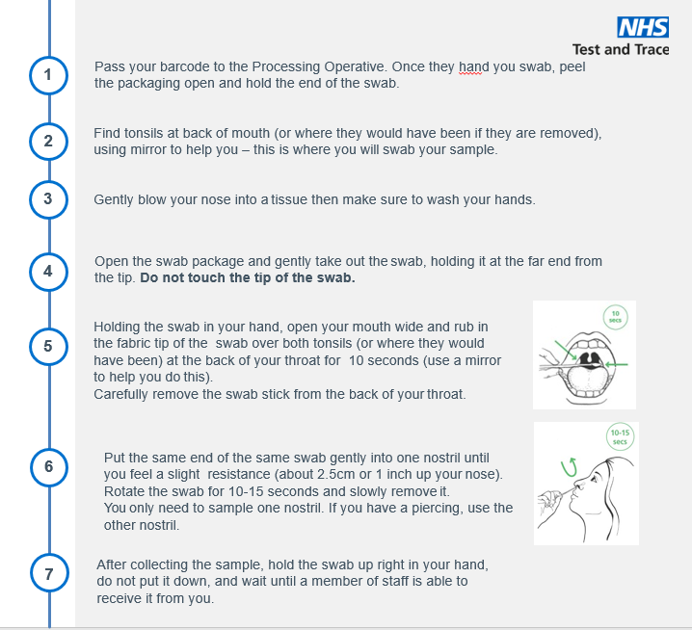
Pictorial Guide – Self-swabbing instructions

Pictorial Guide – Putting on and removing PPE
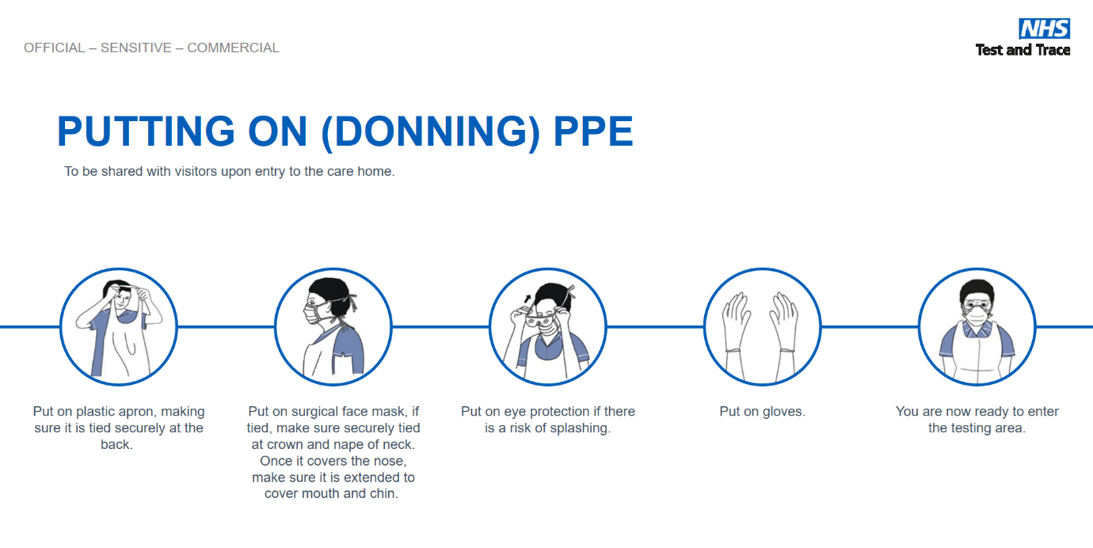

Pictorial Guide: Test Kit Registration
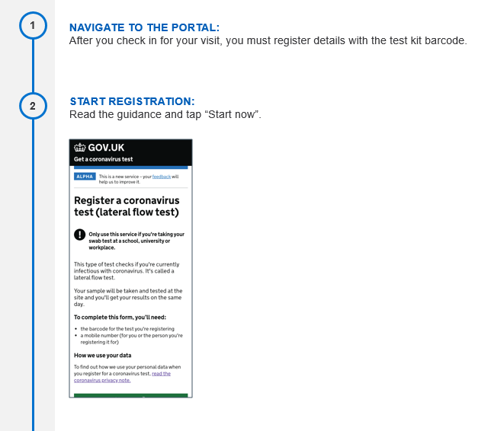
gov.uk/enter-lateral-flow-test

